Basic Programming Tasks

Name: Lochlan Marchinko

Give an example of each of the following concepts in the c# language. Write the code, screenshot it and add it to this document:

1.How to print a message:



2.How to take int or double input from the user:



3.How to take a string input from the user:



4.How to declare and initialize a boolean type:

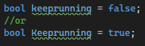

5.How to declare and use arrays:

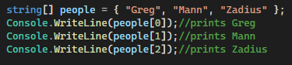

Or

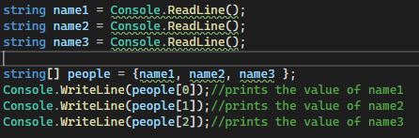

6.How to use the if conditional statement:



7.How to use the if else conditional statement:

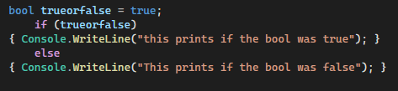

8.how to use a switch statement:

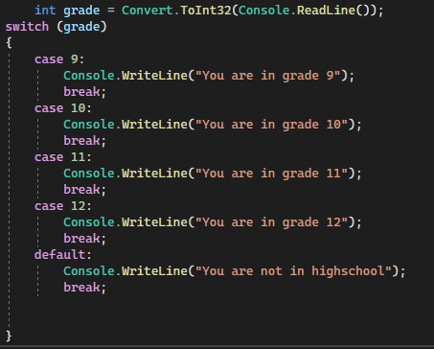

9.How to use the goto label to create a loop:

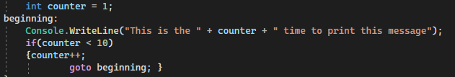

10.How to use for loops:



11. How to use while loops:

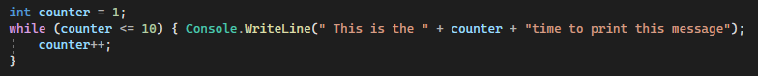

Or

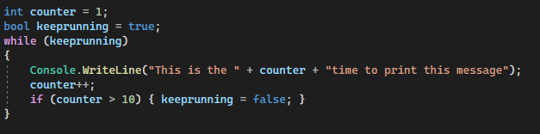

12.How to use do while loops:

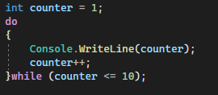

13. How to use foreach with an array:

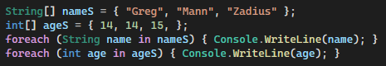

How to turn a label into a box

Step1. Click on the label then change its borderstyle property to fixed single



Step 2. Change the Autosize property of the label to false



Step3. Delete the text property of the label . I.e., make it empty by default



17. How to make the form fixed i.e., prevent the user from resizing it

Step: Change the formborderStyle property from Sizable to FixedSingle or Fixed3D or whatever is required by Mr. S



18. How to get the Form to do something when it loads

Step1. Find the load event for the form



Step2: Double click on the empty space to create a function that handles the load event



Step3: Program or write what needs to happen

19. How to get the Form to do something when it is closing

Step1. Find the formClosing event for the form



Step2: double click on the empty space to create a function that handles the closing event



Step3: Program or write what needs to happen when the form is closing

19. How to use a message box

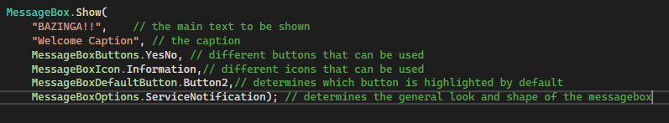

22. How to remove the control box from the form

Step1: locate the controlbox property of the form



Step2: change the value from true to false

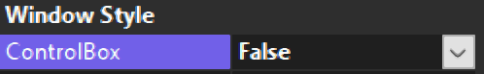

23. How to make an exit button that closes the current form

Step1: make a button and change the text property to say “Exit”



Step2: Double click on the button and write the following in its event handler function

